**Exploratory Analysis**

Addressed the following questions: What users listen to the most? How many play counts? How many unique songs?

**Top 10 Artists By Users // My Naïve Recommendation for users to listen to these artists**

**Top 10 Songs // Naïve Recommendation for a new net user**

**Issue of Data Sparsity (Lots of Users and Items, but few interactions)**

**Another Naïve Recommendation for users if they want to see diversity for artists**

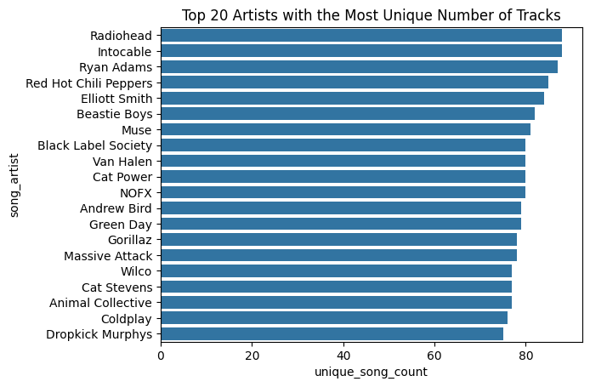

**Introduction to underground artists**

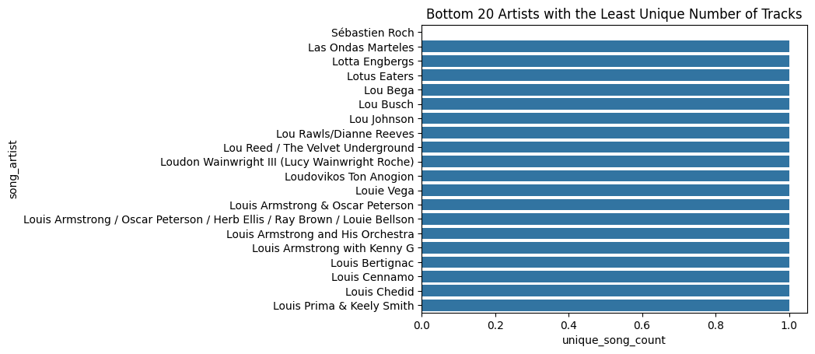

**Distribution of ratings**

**Top 25 most common artists by count // naïve recommendation**

**Introduction to underground artists**

**Top 25 song names by count // naïve recommendation**

**Introduction to unheard of song names**

**BaselineOnly() SVD without K-Fold**

I created a very basic model without hyper parameterizing nor turning the variables to see what potential this model stands in regard to performance and accuracy, and how we can make improvements.

**Difference in metrics**

**My Song List**

**My First Recommendation**

**Predictions and Addressing Accuracy**

I highlight the poor performance of the model with some tables of songs that my peer and I had. Along with some songs from other users to see where things went wrong.

**Lack of diversity in music recommendations**

**BaselineOnly() SVD with K-Fold**

I show the best parameters along with the metrics of the model. Then, I make predictions with the model to see what improvements have been made. The differences are small in selecting the right metrics, hence the recommendations won’t improve by much.

**Predictions and Addressing Accuracy**

I address the recommendations of the model by looking at tables, and highlight the growing concerns of model performance.

**My second recommendation**

**Eric’s Song List**

**Eric’s second recommendation**

**Repeating Song Recommendations for Random Users**

**KNN Recommendations**

Show comparing results from the KNN Model, and by the way the data has a small sample size.

**Non-personalized recommendations from KNN Model**

**Naïve Recommendation (Cold Start Problem)**

Offer my top ten recommendations for a new user with no play count or tracks, addressing the cold start problem.

**Naïve Recommendation 1: Top 10 Most Popular Songs by Play Count**

**Naïve Recommendation 2: Most Popular Artists’ Most Played Song**

